2019Aug19 HOWTO Provision IWP Developer Environment

Screenshots

1. Git clone a copy of the repository down.  I like to use the SSH method, but HTTPS also works.

$ git clone [git@github.com](mailto:git@github.com):ntbrock/iwphys.git

1. Install Oracle Java JDK 8 locally on your laptops.   OpenJDK 11 may work as well if you want to test it.

<https://www.oracle.com/technetwork/java/javase/downloads/jdk8-downloads-2133151.html>

1. Install sbt on your laptops.  It’s built for many operating systems, here’s the install instructions for Mac: <https://www.scala-sbt.org/1.x/docs/Installing-sbt-on-Mac.html>

1. In your project clone, go to the ‘play-version6’ folder and run :  sbt compile.   This should begin downloading around 100MB of project dependencies.

(Screenshot below)

1. In your project clone, go to sbt-verrsion4 and run ‘sbt publishLocal’ to fix the missing dependency in the play-verrsion6 build.

## Required Software

OpenJDK 12

<https://jdk.java.net/12/>

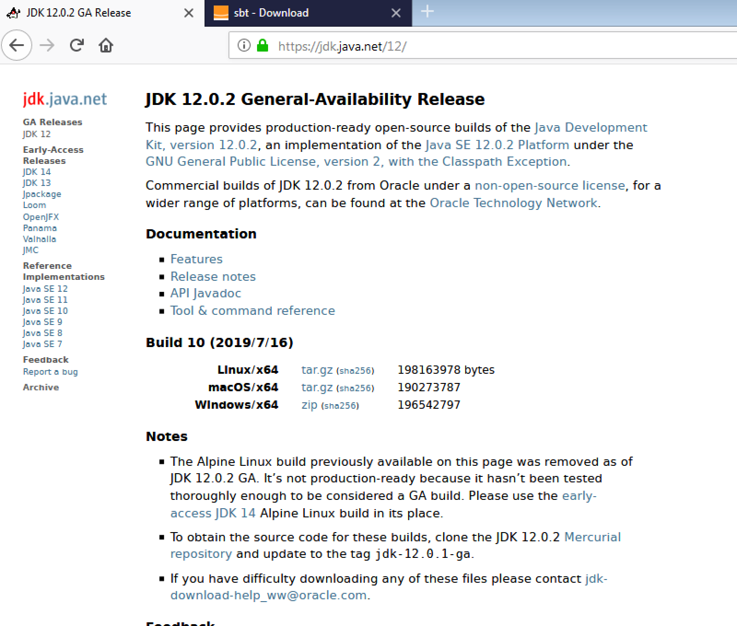

Unzipped into C:\Program Files\jdk-12.0.2

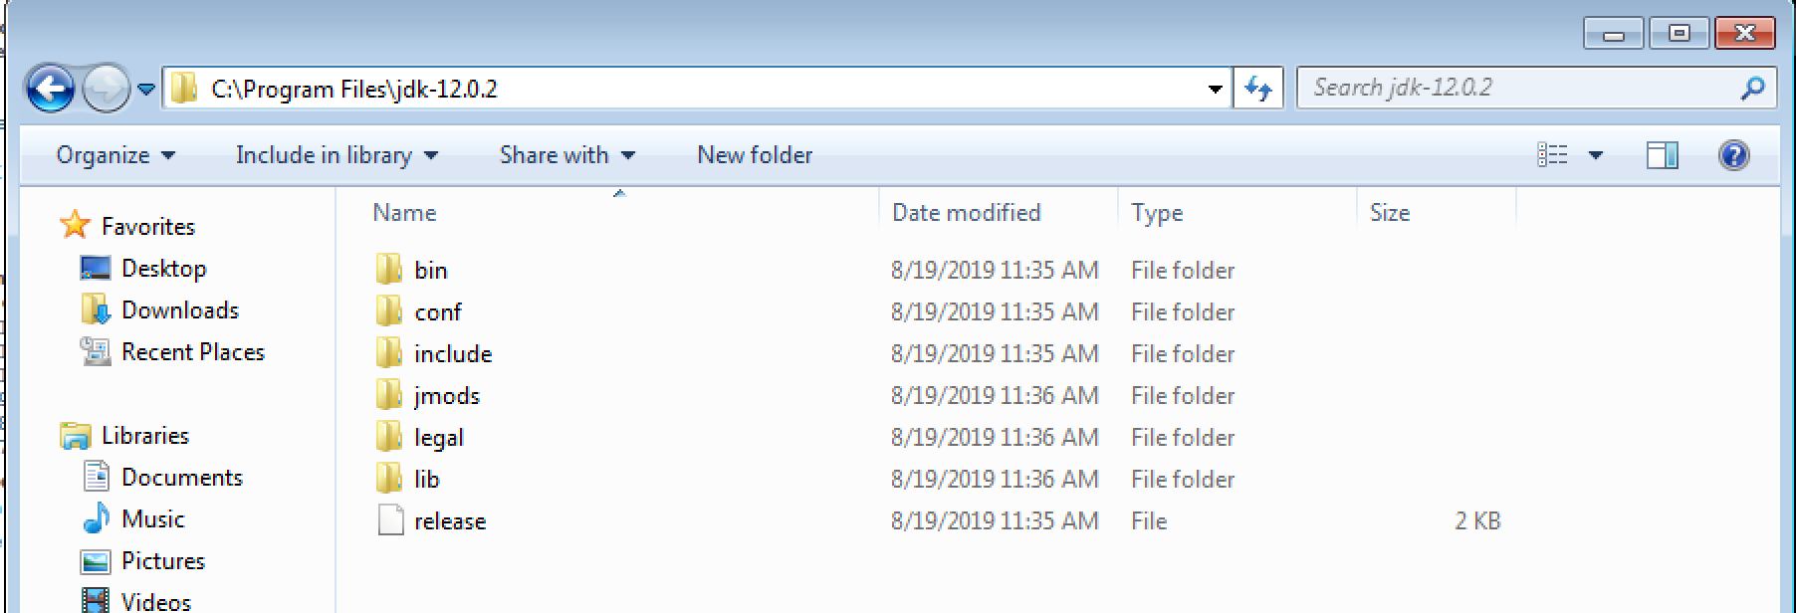

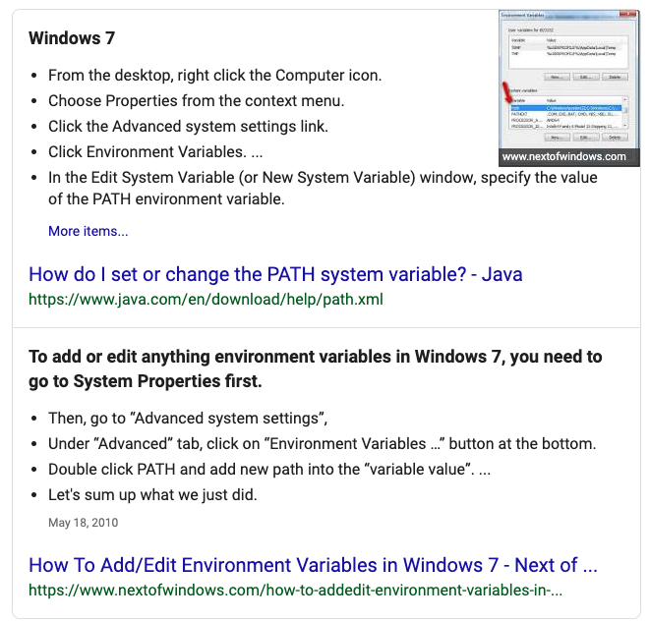

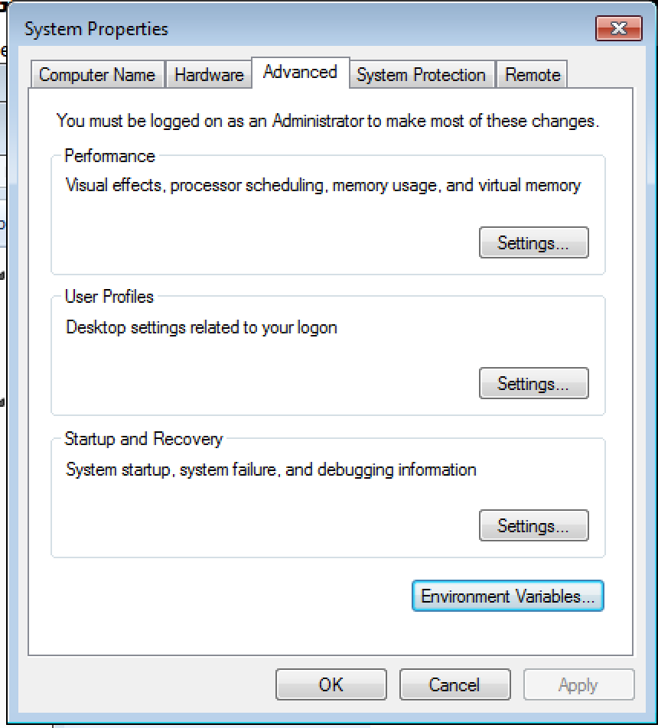

<https://www.oracle.com/technetwork/java/javase/downloads/jdk8-downloads-2133151.html>

Add JAVA_HOME global

Add PATH for user

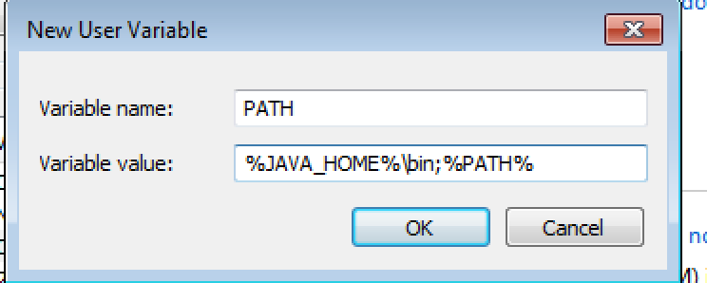

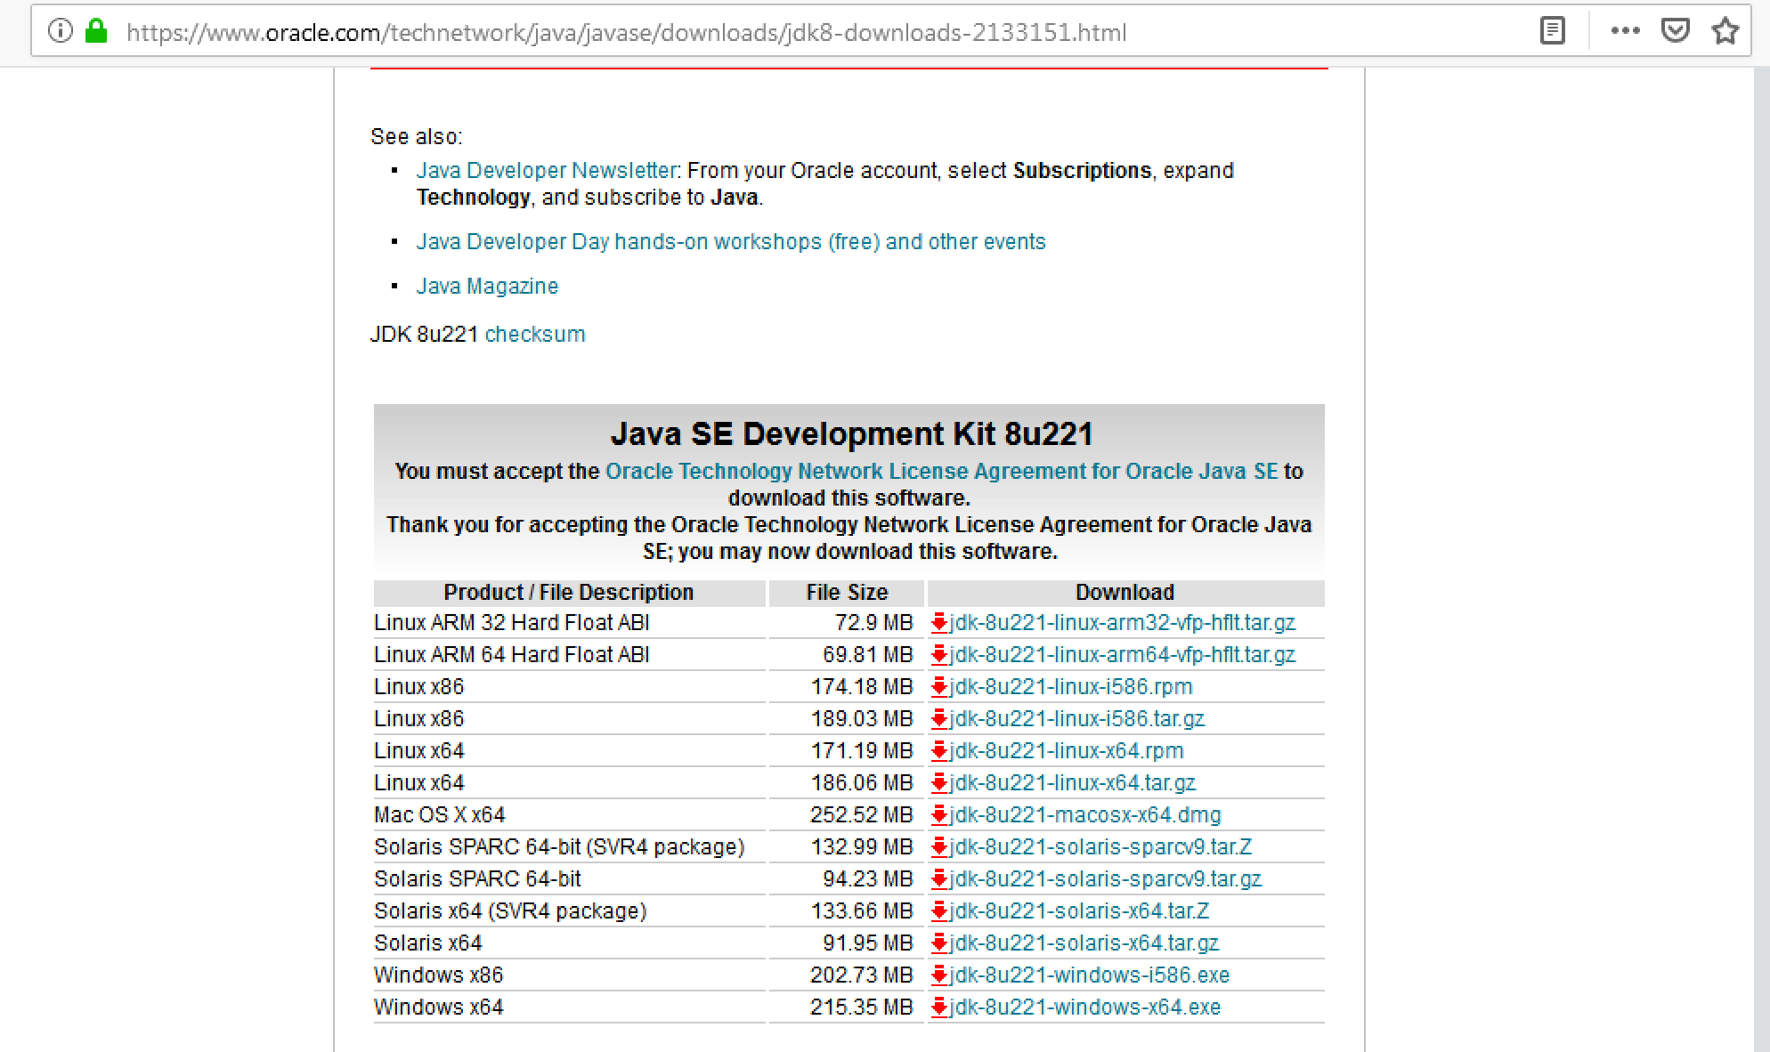

SBT (Simple Build Tool)

<https://www.scala-sbt.org/download.html>

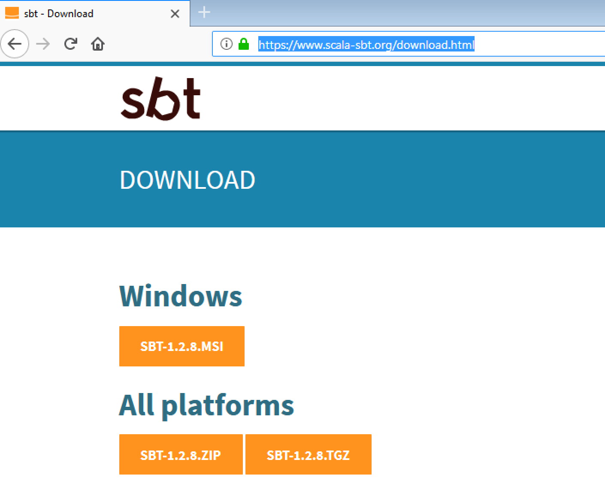

Git for Windows

<https://git-scm.com/download/win>

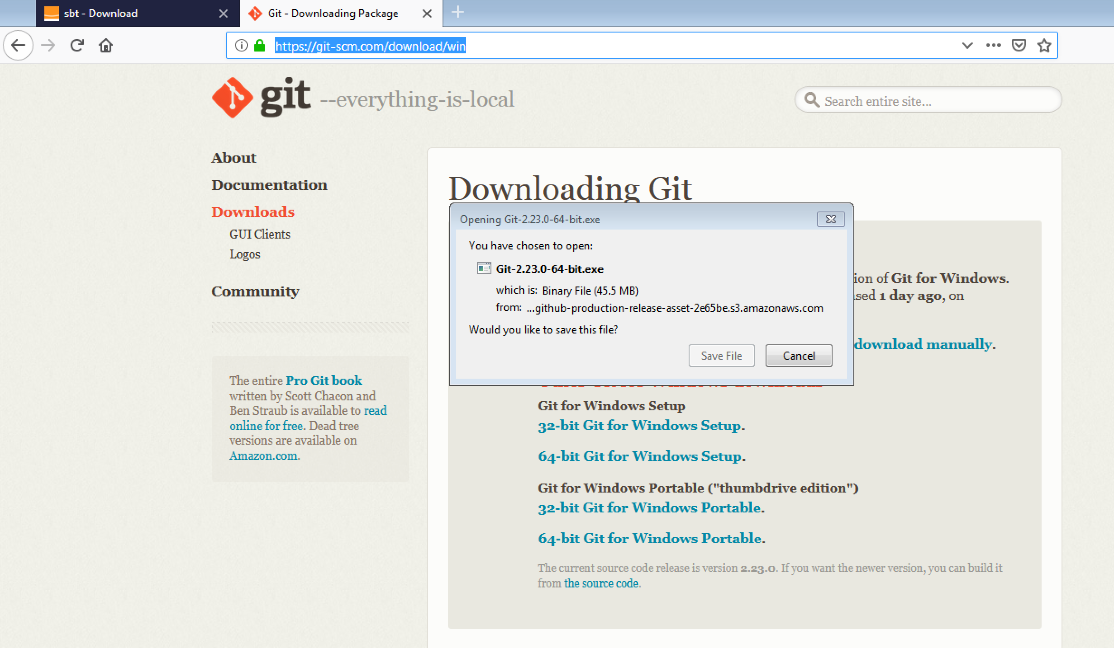

## Git Setup

Run Git BASH Terminal

$ ssh-keygen.exe

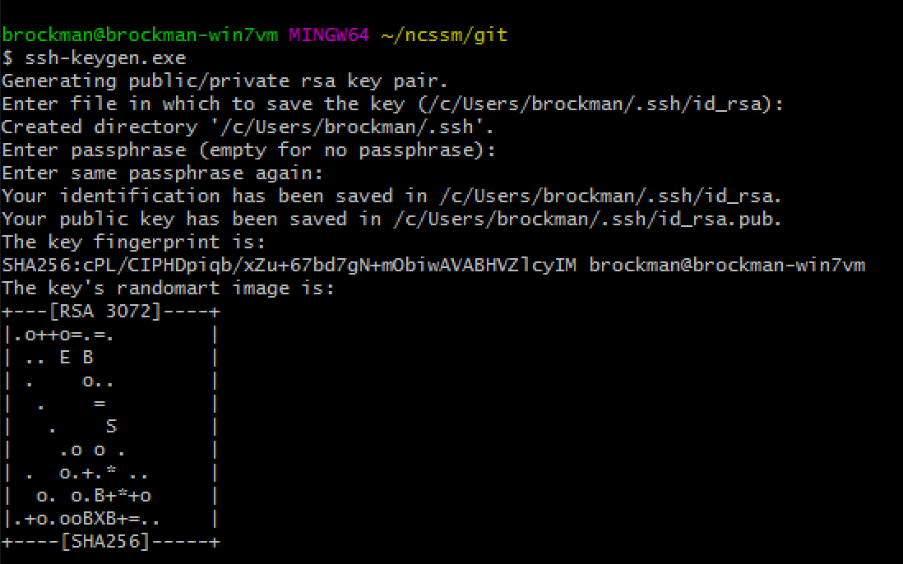

$ cat /c/Users/brockman/.ssh/id_rsa.pub

ssh-rsa  brockman@brockman-win7vm

Paste this into Github > User Profile > Settings > SSH and GPG Keys

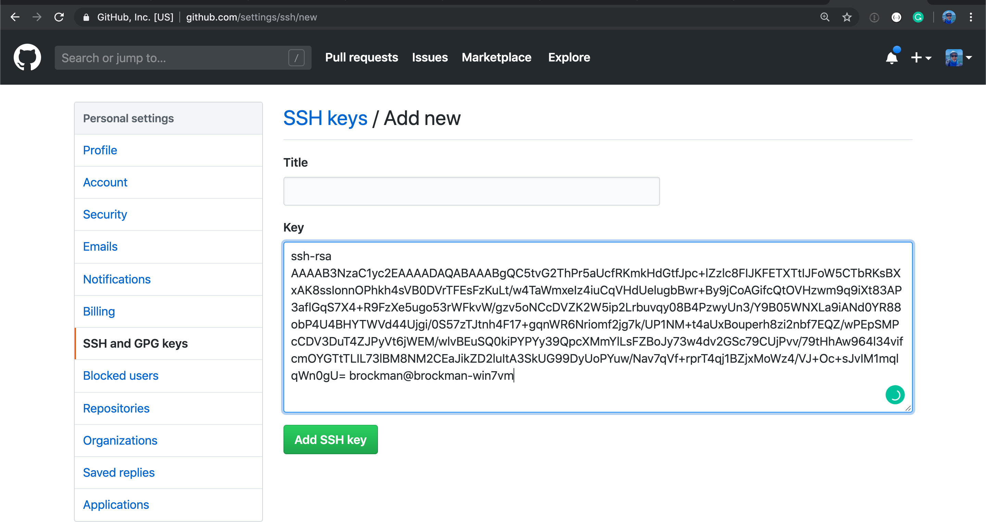

$ mkdir -p ncssm/git

$ cd ncssm/git

$ git clone [git@github.com:ntbrock/iwphys.git](mailto:git@github.com:ntbrock/iwphys.git)

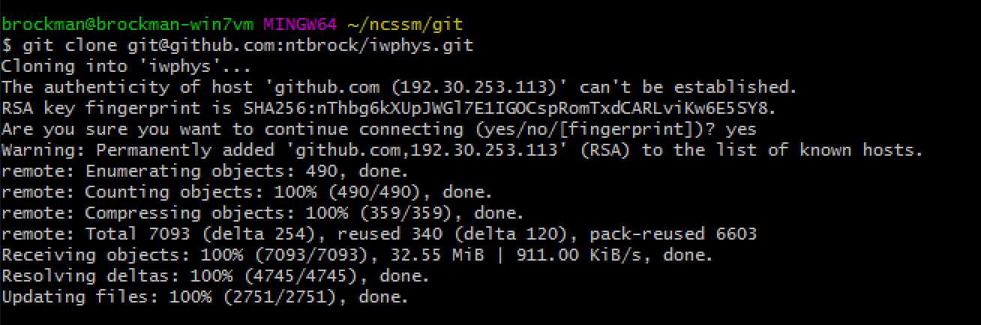

## First SBT Compile

$ sbt compile

First compile fails with missing local dependency:

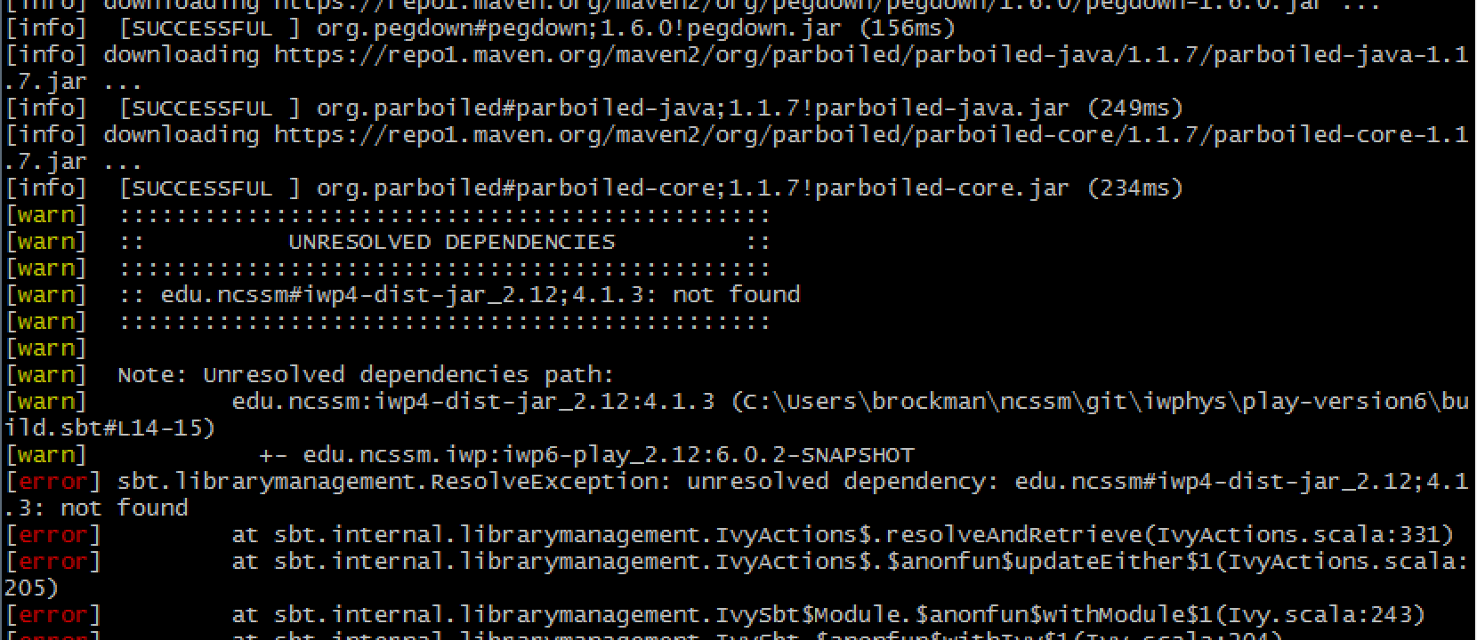

$ cd ../sbt-version4

$ sbt publishLocal

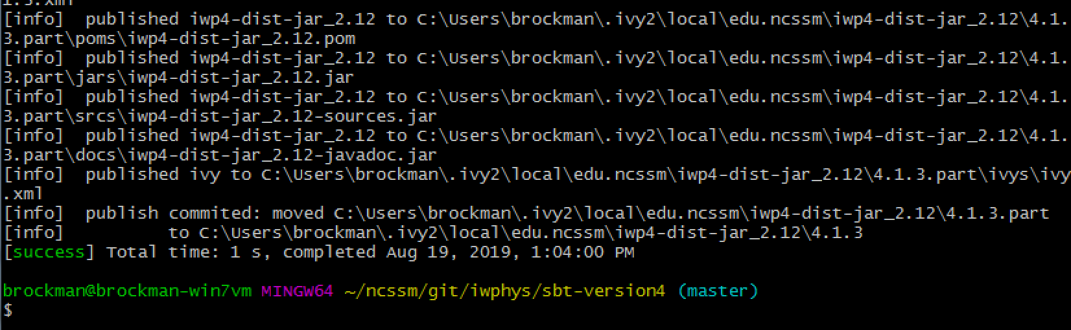

$ cd ../play-version6

$ sbt compile

## Running the Play Daemon

$ sbt run

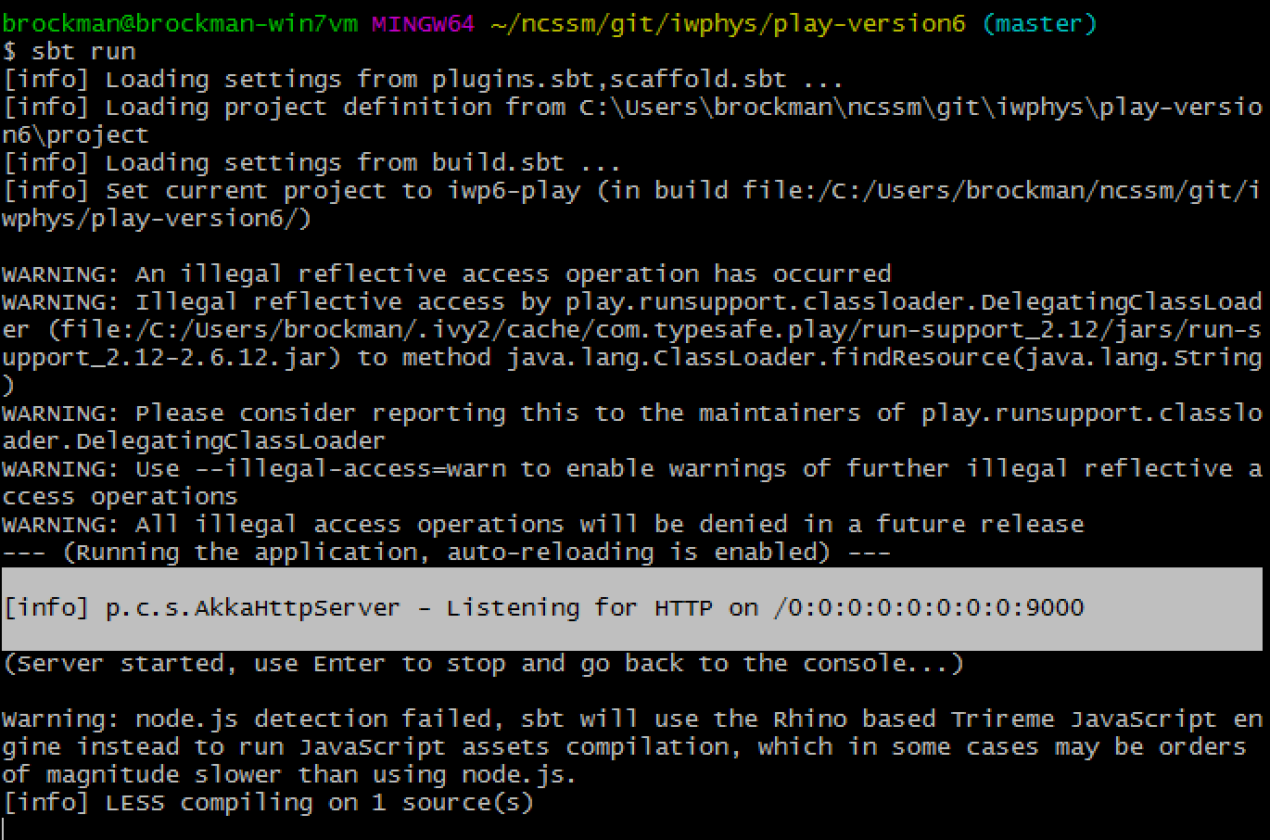

Allow Access in Windows Firewall Prompts

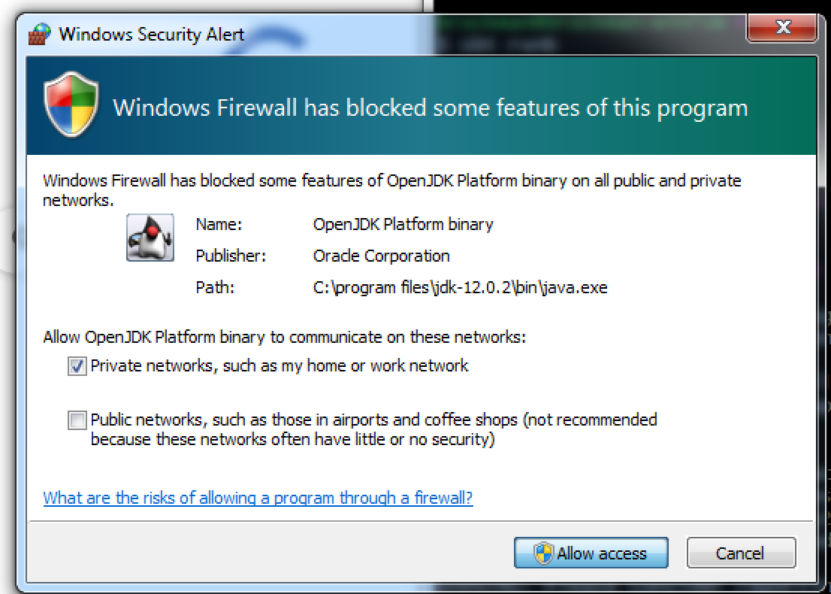

Point your web browser at <http://localhost:9000>

## Developing on Windows

This is what my screen looks like:

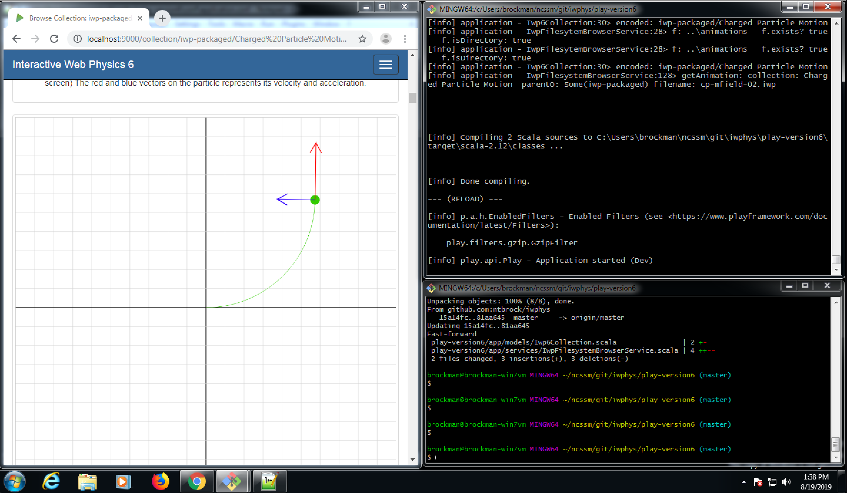

The top right terminal runs my $ sbt run process, t he bottom right terminal is interactive for doing git pull / git push.

## IntelliJ Community Edition

<https://www.jetbrains.com/idea/download/>

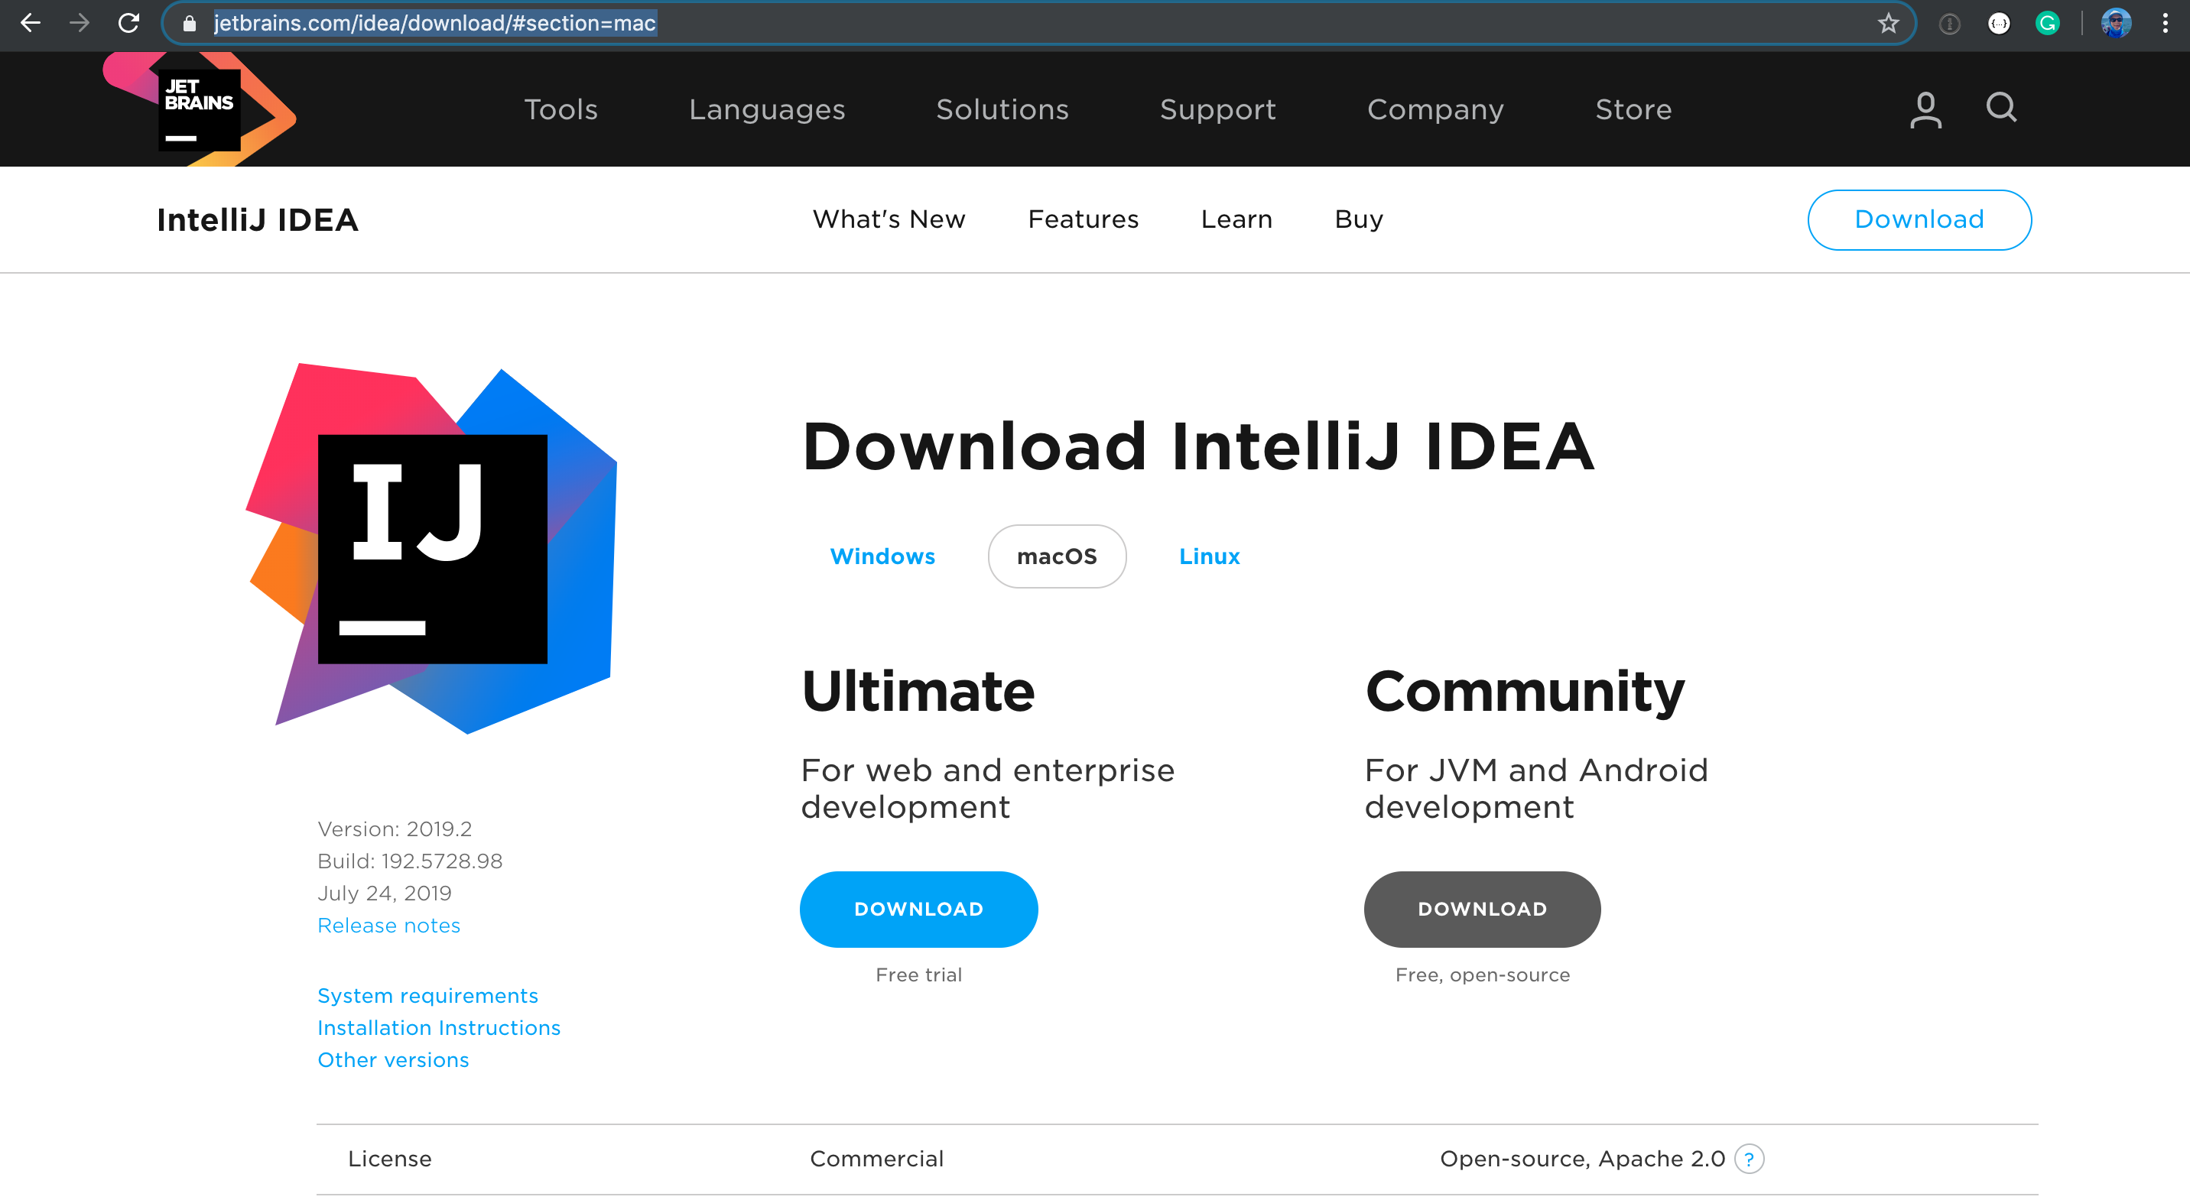

+ Install Scala Plugin

<https://www.jetbrains.com/help/idea/discover-intellij-idea-for-scala.html>

